Simón Bolívar
Simón Bolívar, a wealthy Creole from Venezuela, is considered one of the most important fathers of independence in South America. He led or assisted in the fight for independence from Spain in Venezuela, Columbia, Peru and Bolivia (which is named after him). This is part of the translated text of a speech that Bolívar gave to the Congress of Angostura in 1819, which was meeting for the purpose of creating a Venezuelan constitution.

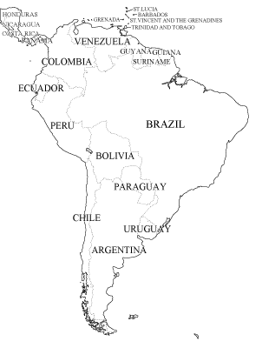
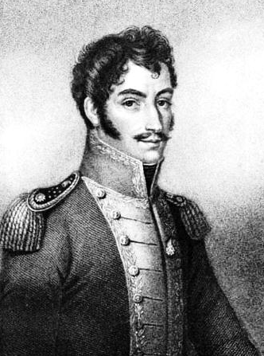
We are not Europeans; we are not Indians; we are but a mixed species of aborigines and Spaniards. Americans by birth and Europeans by law, we find ourselves engaged in a dual conflict: we are disputing with the natives for titles of land ownership, and at the same time we are struggling to maintain ourselves in the country that gave us birth, against the opposition of the invaders. Thus our position is most extraordinary and complicated. But there is more. As our role has always been strictly passive, we find that our quest for liberty is now even more difficult; for we, having been placed in a state lower than slavery, have been robbed not only of our freedom but also of the right to exercise an active domestic domination . . .We have been ruled more by deceit than by force, and we have been degraded more by corruption than by superstition. Slavery is the daughter of darkness: an ignorant people is a blind instrument of its own destruction. Ambition and intrigue abuses the credulity and experience of men lacking all political, economic, and civic knowledge; they adopt pure illusion as reality; they take license for liberty, treachery for patriotism, and vengeance for justice. If a people, perverted by their training, succeed in achieving their liberty, they will soon lose it, for it would be of no avail to endeavor to explain to them that happiness consists in the practice of virtue; that the rule of law is more powerful than the rule of tyrants, because, as the laws are more inflexible, everyone should submit to their beneficent austerity; that proper morals, and not force, are the bases of law; and that to practice justice is to practice liberty.
Although those people [North Americans], so lacking in many respects, are unique in the history of mankind, it is a marvel, I repeat, that so weak and complicated a government as the federal system has managed to govern them in the difficult and trying circumstances of their past. But, regardless of the effectiveness of this form of government with respect to North America, I must say that it has never for a moment entered my mind to compare the position and character of two states as dissimilar as the English-American and the Spanish-American. Would it not be most difficult to apply to Spain the English system of political, civil, and religious liberty: Hence, it would be even more difficult to adapt to Venezuela the laws of North America.
...Therefore, let the entire system of government be strengthened, and let the balance of power be drawn up in such a manner that it will be permanent and incapable of decay because of its own strength. No form of government is as weak as a democracy, so its framework must be firmer, and its institutions must be studied to determine their degree of stability...unless this is done, we will have to reckon with an ungovernable, tumultuous, and anarchic society, instead of a social order where happiness, peace, and justice prevail.

